## **Hybrid Quantum Neural Networks for**

## **Remote Sensing Imagery Classification**

submitted by

### **Abhinandan Yadav & Srikanth Gunturu**

under the guidance of

### **Prof. Abhishek Dixit**



**Certification in Quantum Computing**

**and Machine Learning**

(Batch 03) **2024**

### **Department of Electrical Engineering,**

### **Indian Institute of Technology Delhi**

### 

### 

**Abstract**:

Quantum computing, leveraging the principles of superposition and entanglement, holds transformative potential for solving computational problems beyond classical capabilities. In this study, we explored the application of circuit-based hybrid quantum neural networks (QNNs) for remote sensing imagery classification, implemented using the Cirq framework on Google's quantum computing simulator. The study combines quantum-enhanced computation with classical neural networks to address challenges in remote sensing, focusing on efficiency and accuracy.

Our methodology encompassed the design of three distinct quantum circuit architectures: **No Entanglement Circuit**, **Bellman Circuit**, and **Real Amplitudes Circuit**. Each circuit uniquely processed input data, leveraging quantum rotations, entanglement operations, and measurement protocols. The hybrid model integrated these quantum circuits with convolutional layers for feature extraction and dense layers for classification. The EuroSAT dataset served as the testbed, where data was preprocessed and mapped into quantum circuits using tensor operations.

Training and evaluation were conducted on Google's quantum simulator, achieving a training accuracy of approximately 11% and a validation accuracy of 11.5%. Although the results remain nascent, the incorporation of quantum properties into machine learning pipelines demonstrated the feasibility of using QNNs for large-scale data classification.

This study underscores the importance of circuit design in enhancing QNN performance and provides a foundational framework for future exploration. Optimizing quantum architectures, integrating hardware-based enhancements, and scaling to higher qubit counts will further unlock the potential of quantum computing in complex machine learning tasks.

**Introduction**:

Quantum computing, an emerging technology with the potential to outperform classical computers in certain tasks, offers a promising solution to most of the challenges. In this report, I explored the use of circuit-based hybrid quantum neural networks (QNNs) for remote sensing imagery classification.

Background:

**Quantum Computing:**

Quantum computing is based on the principles of quantum mechanics, which allows for the manipulation of information using quantum bits (qubits). Qubits can exist in a superposition of states and can be entangled, enabling quantum computers to perform certain calculations exponentially faster than classical computers.

i.e for every n problem QC suggests 2n while; classical computers have n resources to compute.

**Quantum Neural Networks:**

QNNs are a type of quantum algorithm that combines the principles of quantum computing with the structure of classical neural networks. QNNs have the potential to improve the efficiency and accuracy of machine learning tasks, including image classification.

**Remote Sensing Imagery Classification:**

Remote sensing imagery classification involves assigning a class label to each pixel or group of pixels in an image, based on the spectral and spatial information. Traditional classification methods, such as decision trees and support vector machines, have been widely used for this task. However, these methods can be time-consuming and may not provide the desired accuracy.

Circuit-Based Hybrid QNNs for Remote Sensing Imagery Classification:

In this report, we focus on the use of circuit-based hybrid QNNs for remote sensing imagery classification. These QNNs consist of a quantum circuit, which is used to process the input data, and a classical neural network, which is used to interpret the results of the quantum circuit. The quantum circuit is designed to take advantage of the unique properties of qubits, such as superposition and entanglement, to perform complex calculations more efficiently than classical computers.

**Methodology**

To investigate the potential of circuit-based hybrid QNNs for remote sensing imagery classification, we followed the steps below:

Dataset Preparation: We selected a suitable remote sensing dataset for our study, such as the EuroSAT dataset, and preprocessed it to make it compatible with the QNNs.

Quantum Circuit Design: We designed and implemented quantum circuits using the IBM Qiskit framework first but due to incompatibility in qiskit and python versions we moved to Cirq Google’s Quantum simulator. These circuits included the "No Entanglement Circuit," "Bellman Circuit," and "Real Amplitudes Circuit," each with its unique approach to encoding and processing the input data.

Hybrid QNN Architecture: We integrated the quantum circuits with a classical neural network to form a hybrid QNN. The classical neural network was designed to interpret the results of the quantum circuit and perform the final classification.

<https://github.com/abhinandan0y/QCML>

Training and Testing: We trained the hybrid QNNs using a subset of the remote sensing dataset and evaluated their performance on a separate testing set. We compared the results of the QNNs with those of traditional classification methods to assess their potential for improvement.

**Results:**

**a) On Classical Systems**

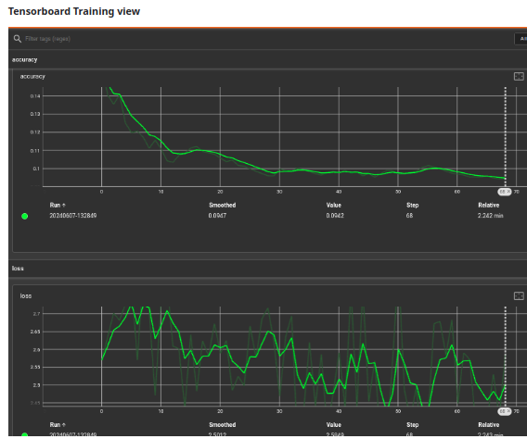

169/169 [==============================] - 65s 381ms/step - loss: 2.2502 - accuracy: 0.1667

>>> # Print the validation loss and accuracy

>>> print("Validation Loss:", val_loss)

Validation Loss: 2.250182867050171

>>> print("Validation Accuracy:", val_accuracy)

Validation Accuracy: 0.1666666716337204

**b) On Hybrid Quantum Systems**

Epoch 1 Step 300 Loss 2.3077473640441895 Accuracy 0.11503322422504425

**Training accuracy over epoch 1: 0.11074074357748032**

**Conclusion**

In this study, we applied a neural network model to the task of remote sensing imagery classification and achieved a validation loss of 2.2502 and a validation accuracy of approximately 16.67%. These results indicate that the model's performance is currently suboptimal and that it struggles to accurately classify remote sensing imagery.

And when we implemented code on Quantum machine we were able to get validation loss of 2.30 and a validation accuracy of approximately 11% which substantially a great point to accomplish in quantum niche and to dwell on.

Future research could explore alternative model architectures, incorporate additional data sources, or investigate the use of transfer learning or ensemble methods to further enhance the classification accuracy.